**Cricket Health Benefits**

**Advantages to playing cricket**

A fantastic team sport is cricket. We all enjoy watching cricket and often get giddy when watching our favourite team. Some fervent enthusiasts, nevertheless, really start the game themselves. Despite the growing popularity of the sport, which is played in gully cricket, school competitions, and interstate tournaments, there are other advantages to playing cricket which are difficult to overlook. **Thetidkes** has good quality [cricket equipment](https://thetidkes.com/shop/) online in India at the best price. A good Discover additional information about the health advantages of playing cricket by reading on.

**Physical Advantages of Cricket**

Cricket is healthy for the muscles and body. Cricket provides the following physical advantages:

**1. Endurance**

In order to bowl your ball, you must race between the wickets and down your bowling lineup or merely pursuing the ball save the important runs. The continuous running here on field helps build endurance.

**2. Stamina**

Every cricket match, whether it be a casual match or a scheduled 20-over, 50-over, or 5-day test series, features lengthy playing sessions. The increased stamina makes it easier to play extended innings of cricket while still being energetic and agile, which increases the body's ability to tolerate wear and strain.

**3. Stability**

The game demands the utmost level of focus, which improves stability and balance. The physical and psychological balance of body are important for playing cricket. In reality, balance is the foundation of any athletic skill because it governs all other motions of the body.

**4. Good Hand-Eye Coordination**

Playing cricket has a number of benefits, including Movement of the hands and eyes must be synchronised. The ball is released by the bowler, the batsman executes the stroke, and the fielder dashes to seize it. The game needs perfect eye-hand coordination for every action, which promotes the general growth and equilibrium of the body.

**5. Burn Calories**

Cricketing is an excellent full-body workout for beginners because it increases calorie expenditure. Given their busy schedules and rigorous training regimen, professional cricket players adhere to an even stricter fitness programme.

**6. Muscle Development**

Every move a player does during a game, including hitting, pitching, running, throwing, and catching, involves a unique collection of muscles. This promotes general muscular growth and provides the body its ideal contour.

**7. Adaptability**

Similar to how the cricket pitch is shaped, playing cricket is good for your health in all directions. To stay ahead of the game, the player must move with exceptional agility and flexibility. Additionally, increased flexibility results in longer muscles, which reduces the risk of injuries from overstretching the muscles.

**8. Heart Wellness**

Cricket has evenly spaced peaks, unlike other severe physical exercise games that dramatically raise heart rate. Heart health benefits come from peak periods that are brief and are followed by brief recovery periods. Additionally, the periodic increase in heartbeat is beneficial for the heart because it keeps the arteries & blood vessels from becoming blocked.

**9. Motor Capacity**

Cricket is a great sport to play to enhance your motor skills. Although fine motor abilities are equally necessary to using the major body muscles, gross and fine motor skills are still very important.

**10. Metabolism**

As was previously noted, playing cricket puts the complete body through a workout. This encourages the breakdown of lipids, and the energy that is generated as a result is utilised to maintain bodily functions. This enhances metabolism and controls weight growth in a positive way.

**The Psychological Advantages of Cricket**

The intellect also benefits from playing cricket. Buy our best Thetidkes having best quality cricket bat [SS Kashmir Willow Cricket Bat](https://thetidkes.com/product/kashmir-willow-cricket-bat/) at an affordable price.The advantages of playing cricket for one's mental health are:

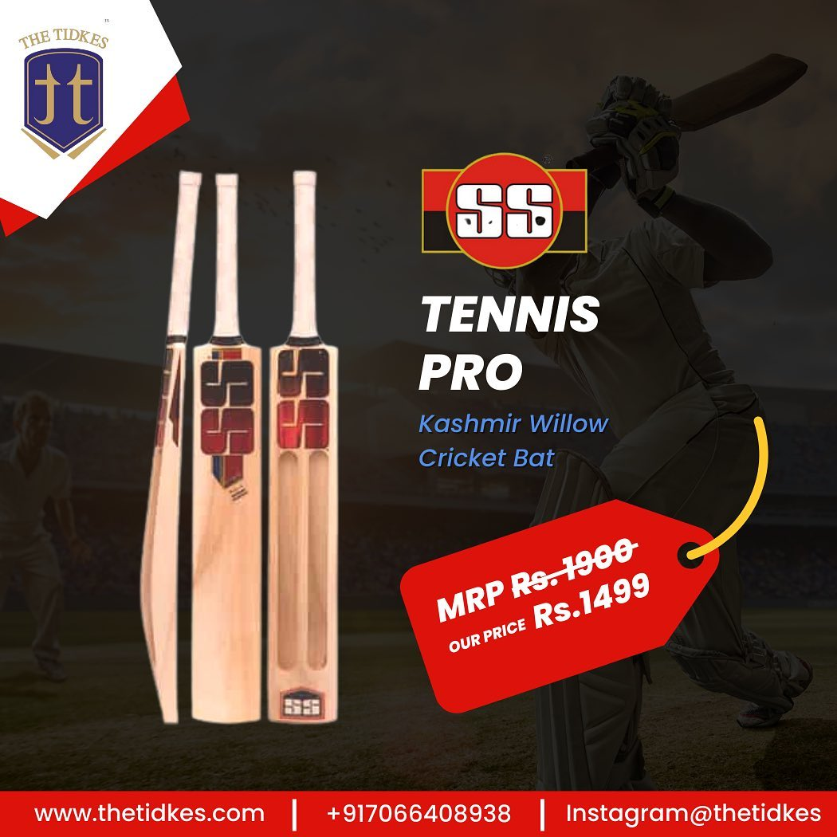

**1. Intense focus**

Cricket is a fast-paced, highly precise game that requires split-second choices. Concentration and sharp judgement are needed for this. This develops the brain's analytical abilities while also making the intellect more acute.

**2. Team Work**

Cricket is a team sport that requires coordination and cooperation. Of 11 players on the field, it takes effective teamwork to come up with a strategy, execute them flawlessly, and help your team win games.

**3. Social Capacity**

You develop social skills by interacting and conversing not only with members of the team but also your rivals. Additionally, even when you lose some games and win others, it provides you the resilience to handle various difficulties and problems in life more skill fully.

**4. Mental Condition**

A person's mental health benefits from playing cricket because it considerably increases focus and attention span. These characteristics support the brain's continued activity and flexibility, which in turn promotes happiness and wellbeing.

**5. Release of Catharsis**

Cricket is a more dangerous sport to express highly charged feelings. Great techniques to unwind and let go of tension include bowling the ideal delivery to remove the batter, hitting the ball hard to send it sailing for a six, as running or dive to remove your opponent.

So go ahead and get the best quality [cricket equipment](https://thetidkes.com/product-category/cricket/) online from our e-commerce site **Thetidkes** at a reasonable price. Thetidkes is one of [best online sport store in india](https://www.thetidkes.com/) that provides original and authentic products. Best sporting brands are also available at the best prices. Thetidkes has the best quality English willow cricket bat and Kashmir willow cricket bat online at an affordable price and even you can have a combo pack also. We have authorized distributors of Cosco, Yonex, Nivia, Spartan, SS, TT, Tennex, Konex and many more Indian and global brands. All sports products and accessories related to Cricket, basketball, volleyball, football, and table tennis are available at THE TIDKES.

You may also visit our website and buy online best quality sports equipment and accessories related to cricket, football, basketball, badminton, volleyball and table tennis.

Carom boards, chess boards, yoga mats and skipping ropes are also available with ‘[THE TIDKES](https://href.li/?https://thetidkes.com/shop/)’. Do visit our retail store, TT SPORTS, at Akola, Maharashtra to find a wide range of sports products and accessories. We are authorized distributors of Cosco, Yonex, Nivia, Spartan, SS, Tennex, Konex and many more Indian and global brands.

You can contact us through social media.

Instagram: [@thetidkes](https://href.li/?https://www.instagram.com/thetidkes)

Facebook: [Tidke Exporters and Traders Private Limited](https://t.umblr.com/redirect?z=https%3A%2F%2Fwww.facebook.com%2Fthetidkes&t=ODRkNDQwZDNiNjJlYzVmYzA5NzFjYjQwNGE2NjE0NDJlN2RmMjRhNixhMTU3Yzg0YWU4OGIzNzZmZjVjMDFmYTA5NGRlMzIyMzU2MmQ2ZTQ1&ts=1671786578" \t "_blank)

